I-20 Monroe (Louisiana) Industrial

Address:
9000 Frontage Road
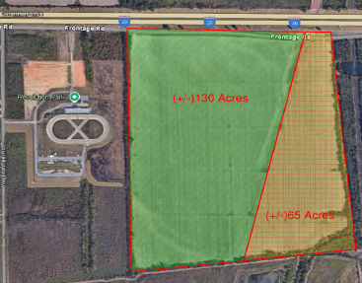
Monroe, LA 71201
(link)

- 195 acres
- Located on the Interstate 20 frontage road with access to multiple interchanges
- Available for sale
- Located in the I-20 Tax Increment Finance (TIF) district.

